Students will learn 1-2 focus TEKS in every content area over the course of the week. These TEKS will be the focus of the lessons provided by teachers. The focus TEKS and additional TEKS for each week will be reinforced in daily activities referenced below. Are Checkpoints for Understanding are questions designed to help gauge student progress toward the learning goal. These daily checkpoints can be found on BLEND.

Week 8 | Monday | Tuesday | Wednesday | Thursday | Friday
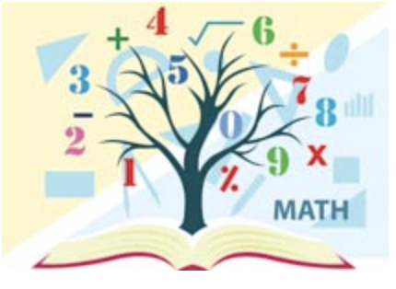  Mathematics  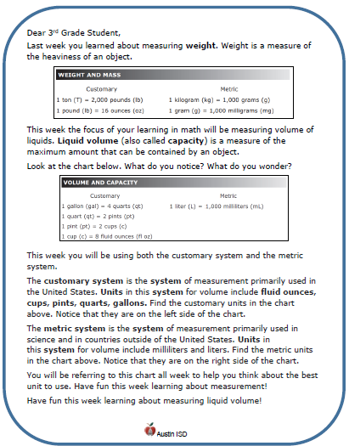  Math Student Overview Page  Click Here | Focus TEKS: 5.4(F) simplify numerical expressions that do not involve exponents, including up to two levels of grouping  Learning Goal(s): I can simplify numerical expressions with two levels of grouping using understandings of models and properties of operations.  Please, use this video as a reference for this week’s math concepts: https://youtu.be/ClYdw4d4OmA  Click here to view all printable pages at once.
 | Activity 1 (Monday)  Checkpoint for understanding#1  Students will examine the relationship between operations and concrete scenarios. | Activity 2 (Tuesday)  Checkpoint for understanding #2  Students will examine the relationship between operations and concrete scenarios and will apply this to STAAR questioning. | Activity 3 (Wednesday)  Checkpoint for understanding #3  Students will review a process to simplify numerical expressions using GEMA. Students will practice applying this to STAAR questioning. | Activity 4 (Thursday)  Checkpoint for understanding #4  Students will review ways to represent multiplication in numerical expressions. Students will practice applying to STAAR questionsing. | Activity 5 (Friday)  Checkpoint for understanding #5  Students will review all material with emphasis on decimals and fractions.Students will practice applying to STAAR questioning.
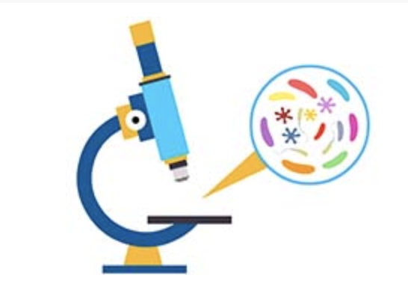  Science | Focus TEKS: 5.9A: observe the way organisms live and survive in their ecosystem ...  5.9B: describe how the flow of energy derived from the Sun, used by producers to create their own food, is transferred through a food chain and food web…  Learning Goal(s): 1. Locate, on a map, where the ecosystem (biome) can be found.  2. Describe the climate (i.e. temperature, precipitation & seasons) of the ecosystem / biome.  3. Draw, name and compare plants from two different ecosystems / biomes.  4. Show the transfer of among organisms in the food web of an ecosystem, using arrows.  5. Identify, name and compare an herbivore and a carnivore from two different ecosystems / biomes
 | Activity:  Watch Wetlands  and/or  Read Wetlands:Swamps  Complete word search activity  KEY  Checkpoint for Understanding:  What characteristics define an ecosystem? | Activity:  Watch Aquatic Plants Identification  and/or  Match Wetland Plant Adaptations  KEY  Checkpoint for Understanding:  What parts of a plant are adapted so the plant can live and survive in its ecosystem? | Activity:  Cut, Paste & Create a Wetland Food Web  Identify the food chains w/in the food web  KEY  Checkpoint for Understanding:  How is energy transferred in an ecosystem? | Activity:  Watch BrainPop:  Everglades  and  Read animal adaptations and  Create a Swamp Creature  Checkpoint for Understanding:  What animals are adapted for the ecosystem? | Activity:  Watch what’s happening at AISD’s Discovery Hill pond.  Search and find Pollutants of the Wetlands  KEY  Checkpoint for Understanding:  How do humans impact ecosystems?

