Students will learn 1-2 focus TEKS in every content area over the course of the week. These TEKS will be the focus of the lessons provided by teachers. The focus TEKS and additional TEKS for each week will be reinforced in daily activities referenced below. The Checkpoints for Understanding are questions designed to help gauge student progress toward the learning goal. These
checkpoints will be answered on BLEND.
Week 7 | Monday | Tuesday | Wednesday | Thursday | Friday
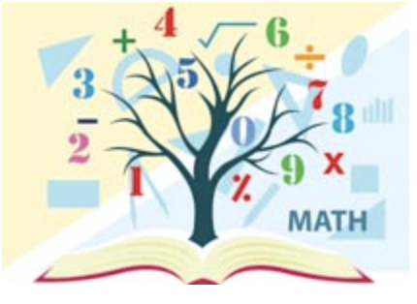  Mathematics  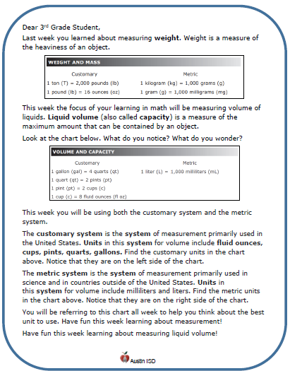  Math Student Overview Page  Click Here | Focus TEKS: 5.3(L) divide whole numbers by unit fractions and unit fractions by whole numbers  Learning Goal(s): I can divide whole numbers by unit fractions and unit fractions by whole numbers using models, real world applications, and properties of operations.  Click here to view all printable pages at once.
 | Activity 1 (Monday) and Checkpoint for understanding #1  Students will split whole models into unit pieces based on real world applications. | Activity 2 (Tuesday) and Checkpoint for understanding #2  Students will continue to practice splitting whole models into unit pieces and will focus on a STAAR application of material. | Activity 3 (Wednesday) and Checkpoint for understanding #3  Students will split a model of a unit fraction into pieces based on real world applications. | Activity 4 (Thursday)and Checkpoint for understanding #4  Students will practice splitting unit fraction models into pieces and will focus on a STAAR application of material. | Activity 5 (Friday) and Checkpoint for understanding #5  Students will review with a focus on determining the dividend for a given situation and trying this application on STAAR material.
Science | Focus TEKS: 5.9A: observe the way organisms live and survive in their ecosystem ...  5.9B: describe how the flow of energy derived from the Sun, used by producers to create their own food, is transferred through a food chain and food web…  Learning Goal(s): 1. Locate, on a map, where the ecosystem (biome) can be found.  2. Describe the climate (i.e. temperature, precipitation & seasons) of the ecosystem / biome.  3. Draw, name and compare plants from two different ecosystems / biomes.  4. Show the transfer of among organisms in the food web of an ecosystem, using arrows.  5. Identify, name and compare an herbivore and a carnivore from two different ecosystems / biomes
 | Activity:  Watch BrainPop:  Deserts  and/or  Read Deserts: Hot & Cold  Complete activity  KEY  Checkpoint for Understanding:  What determines the climate of an ecosystem? | Activity:  Watch BrainPop Jr:  Deserts  and/or  Read Deserts  Draw, color & Explain adaptations of Deserts Plants  KEY  Checkpoint for Understanding:  What parts of a plant are adapted so the plant can live and survive in its ecosystem? | Activity:  Label & color desert animals  Identify food chains w/in the food web  Sonoran Desert Animals  KEY  Checkpoint for Understanding:  What animals are adapted for the ecosystem? | Activity:  Watch BrainPop Jr:  Arctic Habitats  Label & color Arctic Animals  Create a food web  KEY  Checkpoint for Understanding:  How is energy transferred in an ecosystem? | Activity:  Identify, draw and compare Desert & Arctic herbivores and carnivores  KEY  Checkpoint for Understanding:  How are herbivores & carnivores similar between the two ecosystems?

