Students will learn 1-2 focus TEKS in every content area over the course of the week. These TEKS will be the focus of the lessons provided by teachers. The focus TEKS and additional TEKS for each week will be reinforced in daily activities referenced below. Our Checkpoints for Understanding are questions designed to help gauge student progress toward the learning goal. These checkpoints will be answered on BLEND.

Week 6 | Monday | Tuesday | Wednesday | Thursday | Friday
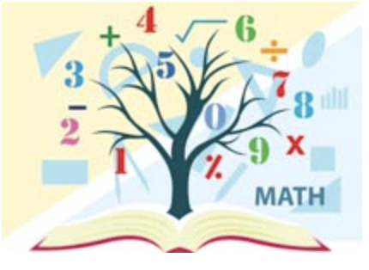  Mathematics  Student Focus Letter | Focus TEKS: 5.3(G) solve for quotients of decimals to the hundredths, up to four-digit dividends and two-digit whole number divisors, using strategies and algorithms, including the standard algorithm  Learning Goal(s): I can divide decimal dividends by whole numbers using models, representations, properties of division and decimals, strategies involving money, and algorithms.  Click here to view all printable pages at once.
 | Activity 1 (Monday) Students will use hundredths grids to divide.  Checkpoint #1 | Activity 2 (Tuesday) Students will use models and groups to divide.  Checkpoint #2 | Activity 3 (Wednesday) Students will use money strategies to divide with decimals.  Checkpoint #3 | Activity 4 (Thursday) Students will divide using long division.  Checkpoint #4 | Activity 5 (Friday) Students will review all ways to divide with decimals.  Checkpoint #5
Science | Focus TEKS: 5.9A: observe the way organisms live and survive in their ecosystem ...  5.9B: describe how the flow of energy derived from the Sun, used by producers to create their own food, is transferred through a food chain and food web…  Learning Goal(s): 1. Locate, on a map, where the ecosystem (biome) can be found.  2. Describe the climate (i.e. temperature, precipitation & seasons) of the ecosystem / biome.  3. Draw, name and compare plants from two different ecosystems / biomes.  4. Show the transfer of among organisms in the food web of an ecosystem, using arrows.  5. Identify, name and compare an herbivore and a carnivore from two different ecosystems / biomes.
 | Activity:  Watch BrainPop Jr:  Grasslands  and/or  Read Grasslands  & answer questions  KEY  Checkpoint for Understanding:  What determines the climate of an ecosystem? | Activity:  Draw, color & explain adaptations of Grassland Plants  KEY  Checkpoint for Understanding:  What parts of a plant are adapted so the plant can live and survive in its ecosystem? | Activity:  Label & color animals from the Prairie and Savanna Animals  KEY  Checkpoint for Understanding:  What animals are adapted for the ecosystem? | Activity:  Create food webs of the Prairie and Savanna Food Webs  KEY  Checkpoint for Understanding:  How is energy transferred in an ecosystem? | Activity:  Identify, draw and compare Grassland herbivores and carnivores  KEY  Checkpoint for Understanding:  How are herbivores & carnivores similar between the two ecosystems?

