Students will learn 1-2 focus TEKS in every content area over the course of the week. These TEKS will be the focus of the lessons provided by teachers. The focus TEKS and additional TEKS for each week will be reinforced in daily activities referenced below. Our Checkpoints for Understanding are questions designed to help gauge student progress toward the learning goal. These checkpoints will be answered on BLEND.
Week 5 | Monday | Tuesday | Wednesday | Thursday | Friday
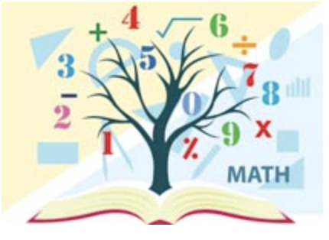  Mathematics  Math Student Overview Page  Click Here | Focus TEKS: 5.3(E) solve for products of decimals to the hundredths, including situations involving money, using strategies based on place-value understandings, properties of operations, and the relationship to the multiplication of whole numbers  Learning Goal(s) I can use a variety of methods, including models, repeated addition, properties of multiplication, estimation and reasoning to solve for products of decimals to the hundredths place.  Click here to view all printable pages at once.
 | - Activity 1 Students will review multiplication of decimals as related to money and repeated addition..  - Checkpoint for Understanding #1 | - Activity 2 Students will practice multiplication with decimals using models and estimation.  - Checkpoint for Understanding #2 | - Activity 3 Students will use area models to multiply a tenth by a tenth.  - Checkpoint for Understanding #3 | - Activity 4 Students will examine the relationship between place value and factors.  - Checkpoint for Understanding #4 | - Activity 5 Students will review multiplying with decimals with a fun “Math Lib” activity.  - Checkpoint for Understanding #5
Science | Focus TEKS: 5.9A Observe the way organisms live and survive in their ecosystem by interacting with the living and non-living elements.  Learning Goal(s): I can…  Explain the difference between a population, ecosystem, habitat and biome  Identify the different characteristics that make up a biome  Tell the different biomes by their descriptions and locate them on a world map  Recognize the food web of a biome based on the organisms that live & survive within it
 | Activity:  Read ScienceSaurus Environments & Ecosystems pp 128-129  Complete Habitats, Ecosystems and Biomes  KEY  Checkpoint for Understanding:  What do populations, ecosystems and habitats have to do with each other? | Activity:  A Scavenger Hunt of Items and Ideas!!!!  Read and Use your house, yard & imagination to describe the biomes.  Checkpoint for Understanding:  What are three factors used in describing a biome? | Activity:  Mapping: Biomes of the World  Color code a world map.  Checkpoint for Understanding:  What patterns do you notice when biomes are identified on a world map? | Activity:  Biomes and their Food Webs  Identify which food webs represents which ecosystem/ biome  KEY  Checkpoint for Understanding:  What do all food webs have in common? | Activity:  Matching Biomes  Apply what you know  KEY  Checkpoint for Understanding:  Which of the biomes seems to be found in more places in the world and cover the most area?

