Students will learn 1-2 focus TEKS in every content area over the course of the week. These TEKS will be the focus of the lessons provided by teachers. The focus TEKS and additional TEKS for each week will be reinforced in daily activities referenced below. Our Checkpoints for Understanding are questions designed to help gauge student progress toward the learning goal. The checkpoints assignments can be found on Blend and are required assignments.

Week 9 | Monday | Tuesday | Wednesday | Thursday | Friday
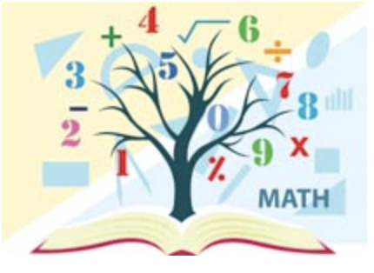  Mathematics  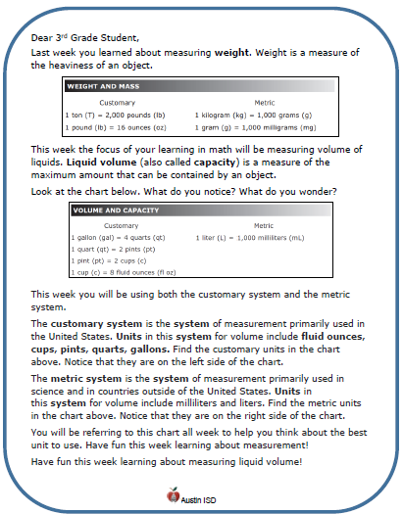  Math Student Overview Page  Click Here | Focus TEKS:  5.4(C) generate a numerical pattern when given a rule in the form y = ax or y = x + a and graph  Learning Goal(s)  - I can recognize an additive and multiplicative number pattern when given a rule in y = form and can graph that number pattern in the coordinate grid.  Please, use this video as a reference for this week’s Math concepts.  https://youtu.be/mqsIJucBn6c  Click here to view all printable pages at once.
 | Activity 1 (Monday)  Checkpoint for understanding#1  Students will review the key aspects of the coordinate grid and locating points in the coordinate grid | Activity 2 (Tuesday)  Checkpoint for understanding #2  Students will examine a pattern based on a real world scenario and will practice representing and graphing this pattern. | Activity 3 (Wednesday)  Checkpoint for understanding #3  Students will examine multiplicative and additive patterns in rule form and will fill in tables for x and y values. | Activity 4 (Thursday)  Checkpoint for understanding #4  Students will now relate the rule to tables and graphs and will practice STAAR application. | Activity 5 (Friday)  Checkpoint for understanding #5  Students will recognize patterns in different forms as additive and multiplicative and will practice STAAR application.
Science | Focus TEKS: 5.9A: observe the way organisms live and survive in their ecosystem ...  5.9B: describe how the flow of energy derived from the Sun, used by producers to create their own food, is transferred through a food chain and food web…  Learning Goal(s): 1. Locate, on a map, where the ecosystem (biome) can be found.  2. Describe the climate (i.e. temperature, precipitation & seasons) of the ecosystem / biome.  3. Draw, name and compare plants from two different ecosystems / biomes.  4. Show the transfer of among organisms in the food web of an ecosystem, using arrows.  5. Identify, name and compare an herbivore and a carnivore from two different ecosystems / biomes
 | Activity:  Watch BrainPop Jr. Forest & Rainforest  and/or  Read Forests: Deciduous, Coniferous & Rainforest  Complete activity  KEY  Checkpoint for Understanding:  What characteristics define an ecosystem? | Activity:  Identify, draw & compare Forest Plants  KEY  Checkpoint for Understanding:  What parts of a plant are adapted so the plant can live and survive in its ecosystem? | Activity:  Color Animals of the Forest and Rainforest  Finish the Rainforest rhyme  KEY  Checkpoint for Understanding:  What animals are adapted for the ecosystem? | Activity:  Create a Recycled Forest Creature  Picture, post and share creation  Understanding:  Making choices in the conservation, disposal, and recycling of materials. | Activity:  re-Watch BrainPop Jr. Forest & Rainforest  Review your activity  documents  Write 3 truths and 1 believable lie about forests  Collect data: test family & friends  Checkpoint for Understanding:  What characteristics define an ecosystem?

