Students will learn 1-2 focus TEKS in every content area over the course of the week. These TEKS will be the focus of the lessons provided by teachers. The focus TEKS and additional TEKS for each week will be reinforced in daily activities referenced below. Our Checkpoints for Understanding are questions designed to help gauge student progress toward the learning goal. These checkpoints will be answered on BLEND.

Week 4 | Monday | Tuesday | Wednesday | Thursday | Friday
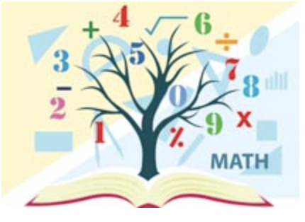  Mathematics  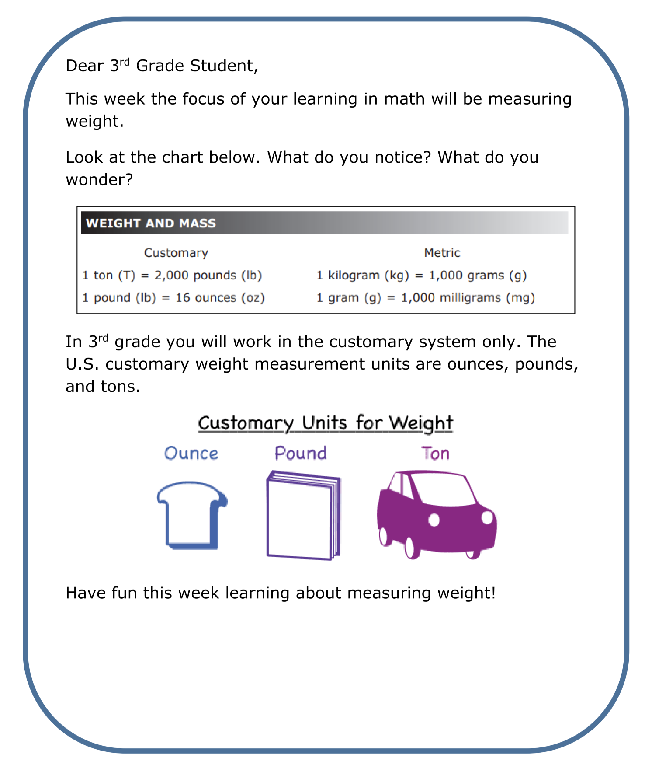  Student Overview Page  Click Here | DreamBox online activities  Each day complete one Lesson (approximately 20 - 30 minutes). Students can login to DreamBox by logging into their portal and clicking on the DreamBox icon.
Focus TEKS: 5.2(B) compare and order two decimals to thousandths and represent comparisons using the symbols >, <, or =

Learning Goal(s): I will be able to compare decimal numbers up to the thousandths place. I will understand the difference between the tenths, hundredths, and thousandths and will be able to represent each place value in different ways.

Click here to view all printable pages at once.
 | - Activity 1: Students will shade and reflect to review tenths and hundredths.  - Checkpoint for Understanding 1: | - Activity 2 Students will practice writing decimals as fractions.  - Checkpoint for Understanding 2: | - Activity 3 Students will review the thousandths place value.  - Checkpoint for Understanding 3 | - Activity 4 Students will review decimals and fractions on a number line.  - Checkpoint for Understanding 4 | - Activity 5 Students review and show what they know.  - Checkpoint for Understanding 5
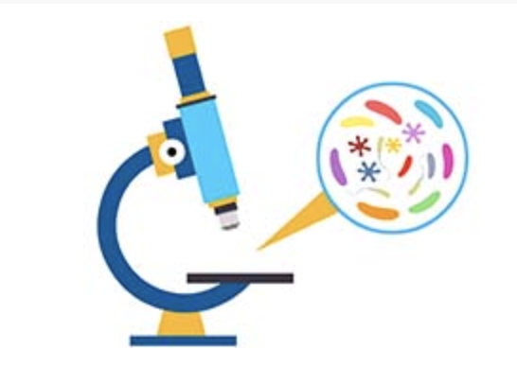  Science | Focus TEKS: 3.10B investigate and compare how animals and plants undergo a series of orderly changes in their diverse life cycles...  Learning Goal(s): Realize that all organisms(plant and animal) have a life cycle that go through multiple stages  Put the stages of different organisms’ life cycles in order  Explain when an organism is an adult (when it can reproduce)  Label the stages of complete and incomplete life cycles (metamorphosis)
 | Activity:  Life Cycles  Cut out, match and create: the life cycles of a frog, butterfly, human and sunflower plant  Complete: the Life Cycles Table  KEY Life Cycles  Checkpoint for Understanding:  What is a life cycle? | Activity:  Read: Tomato Plant Life Cycle  Cut out and paste pictures onto cycle sheet  Color: the drawing.  KEY: Tomato Plant Life Cycle  Checkpoint for Understanding:  How do most plants reproduce? | Activity:  Read: Complete Metamorphosis: Life Cycle of the Butterfly  Label: Stages of Butterfly Life Cycle  Color: the drawing.  KEY: Complete Metamorphosis: Life Cycle of the Butterfly  Checkpoint for Understanding:  How do we know when an organism is an adult? | Activity:  Read: Incomplete Metamorphosis: Life Cycle of the Dragonfly  Label: Stages of Dragonfly Life Cycle  Color: the drawing.  KEY: Complete Metamorphosis: Life Cycle of the Butterfly  Checkpoint for Understanding:  What does metamorphosis mean? | Activity:  Identifying Life Cycles  Match the Life Cycle to the organism  Identify (when asked) if the life cycle is a complete of incomplete metamorphosis  KEY Application Activity  Checkpoint for Understanding:  What is the difference between complete and incomplete metamorphosis?

