Students will learn 1-2 focus TEKS in every content area over the course of the week. These TEKS will be the focus of the lessons provided by teachers. The focus TEKS and additional TEKS for each week will be reinforced in daily activities referenced below. As a special last-week-of-school treat, there are no checkpoint assignments on Blend.

Week 10 | Monday | Tuesday | Wednesday | Thursday | Friday
Mathematics  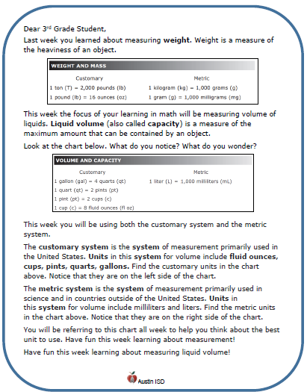  Math Student Overview Page  Click Here | Focus TEKS: 5.4(B) represent and solve multi-step problems involving the four operations with whole numbers using equations with a letter standing for the unknown quantity  Learning Goal(s)  - I can solve for a letter representing an unknown quantity using models and properties of operations.  Click here to view all printable pages at once.
 | Monday  Memorial Day  Student Holiday  Take time to honor the men and women who have died while serving in the military. | Tuesday  Pick at least one activity from the Choice Board | Wednesday  Pick at least one activity from the Choice Board | Thursday  Activity:  Enjoy Track and Field Day !!  Think about how math and/or science might be involved in your Track and Field Day:  force, distance, mass, height, length, speed, time.  Track and Field Ribbon:  Congratulations for participating in the 2020 “Remote” Field & Track Day  Color me a winner!!!!. | Friday  Beginning of Summer Break
Science | Focus TEKS:5.9(C) predict the effects of changes in ecosystems caused by living organisms, including humans, such as the overpopulation of grazers or the building of highways  Learning Goal(s): 1. identify agents of negative impact on an ecosystem or the environment  2. analyze the radiating effects of a negative impact  3. speculate on possible solutions
 | Take time to honor the men and women who have died while serving in the military. | Activity:  Listen to the The Lorax by Dr Seuss  or  Read The Lorax  Write and illustrate the The Lorax the Sequel  KEY  A Lorax message... | Enjoy Track and Field Day !!  Activity:  Think about how science and/or math might be involved in Track and Field Day:  force, distance, mass, height, speed, time. | Congratulations for participating in the 2020 “Remote” Field & Track Day.  Color me a winner!!!! | ------

